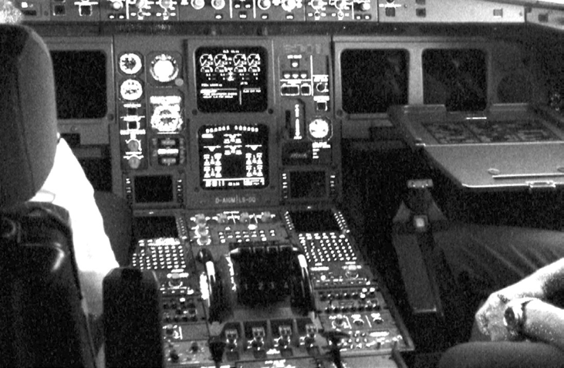

**The Virtual Filesystem - A**

***Objective: In this lab modify the*** sleepkiller ***LKM you made in Lab5 to locate a sleep process and navigate the process filesystem to print the current directory of where it was instantiated.***

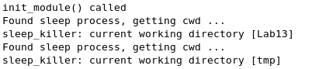

1. Examine the struct task_struct for a filesystem information structure, follow that until you arrive at the current directory reference. Use slides for reference.